Dementia strategy 2018-2021 summary
We are continuing to deliver changes that improve the way in which we care for patients with dementia, and ensure that people experience patient centred care while being treated within our services.
What we will do:
Outcome | Aim
We will support you to get the right health care you need to live a healthy life. | The person is involved as much as possible around decisions regarding their care and treatment.  We will support people with accessible information and communication to suit their needs  Care and support that takes into account a person’s needs, concerns, wishes and preferences.  Helping hands stickers for patients requiring reasonable adjustments  Clear identification of people with dementia in all healthcare record systems.  We have clear flags for dementia on all of our clinical systems
Working in partnership with families and carers. | Recognise and value the voice of carers.  We will ensure that carer and family details are recorded within the persons record  Carers are actively involved and engaged in care planning and decision-making.  We are committed to Johns Campaign which supports carers to stay with their loved ones in hospital  Supporting carers with information on services.  We have representation from people with dementia and carers in Dementia and Learning Disability work group  Supporting carers to have an assessment of their own needs so that they can stay healthy and well.  A new carers policy published in 2018 including how to access support for carers
Look at extra things we need to do, so people with dementia can get health services as good as other people.  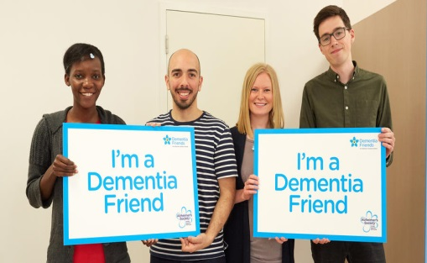 | Making sure that information on health services is accessible to people with dementia  We have the ‘This is Me’ leaflet , easy read literature and patient leaflets available for patients and carers.  Health professionals have improved knowledge and skills to support people.  We will increase training and education for staff on the needs of people with dementia across the Trust  Raise awareness of dementia across the trust.  Dementia awareness events will be held during 2019 and 2020  People are given more time with health care professionals.  We will ensure that reasonable adjustments, including longer appointments are offered to people with Dementia
To have better information | Provide clear and easy to read information about our services.  We will have a range of accessible information resources on services and treatments are available at all hospital sites.  Information available for people on how to get help if they are not happy with the care they have received.  We will support people with dementia and their carers to access support from PALS at Moorfields.

For more detailed information please see our full strategy document.

