Learning Disability Strategy 2018-2022 summary

Our strategy gives us a firm basis for delivering high quality, safe, person centred care, which provides people with learning disabilities and their carers with the most positive experience possible.
What we will do:
Outcome | Aim
We will support you to get the right health care you need to live a healthy life. | The person is involved as much as possible around decisions regarding their care and treatment  Care and support that takes into account a person’s needs, concerns and preferences.  Clear identification of people with learning disabilities in all healthcare record systems
Working in partnership with families, carers and paid carers. | Recognise and value the voice of carers.  Carers being actively involved in care planning and decision-making.  Supporting carers with information on services.  Ensuring that carers have an assessment of their own needs so that they can stay healthy and well.
Look at extra things we need to do, so people with learning disabilities can get health services as good as other people. | Making sure that information on health services is accessible to people with learning disabilities  Health care professionals develop more skills to support people.  Giving people more time with health care professionals
To have better information | Provide clear and easy to read information about our services.  Information available for people on how to get help if they are not happy with the care they have received.
We are committed to supporting the employment of more people with learning disabilities in NHS organisations.  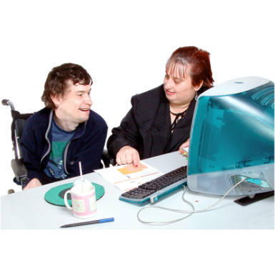 | Demonstrate our commitment to employing people with learning disabilities.

For more detailed information please see our full strategy document.

